**Ethiopia**

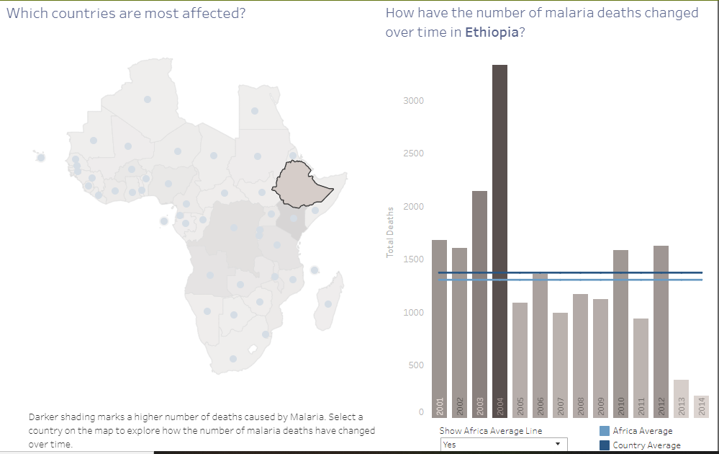

|  |  |
| --- | --- |
| Average deaths every year: | 1,370 |
| Average deaths every day: | 3.75 |

Seeing the data of the Ethiopia:

* The Country has shown a steep increase in the total deaths in the year 2004.
* The death rate decline occurred in the year 2005 to more than half as compared to the previous year.
* Year 2014 has shown least number of deaths in the Country, being the best year since 2001.
* Year 2004 was worst year for the Country with an approximation of more than 3000 deaths
* During the years 2005-2009 the deaths were below the average deaths in the country .
* 2010 was the year which again broke the line of country’s average death after being below the average determined over a period of 5 consecutive years.
* Comparing the country's average to that of Africa's , it is seen that average deaths in the former are more than that of the latter.

**Conclusion :**We can see from the average deaths data , that the Ethiopia is a safer country comparing to other countries in Africa . There was a sudden increase in the death rate in 2004 and was back to its average rate in the country

**Burkina Faso**

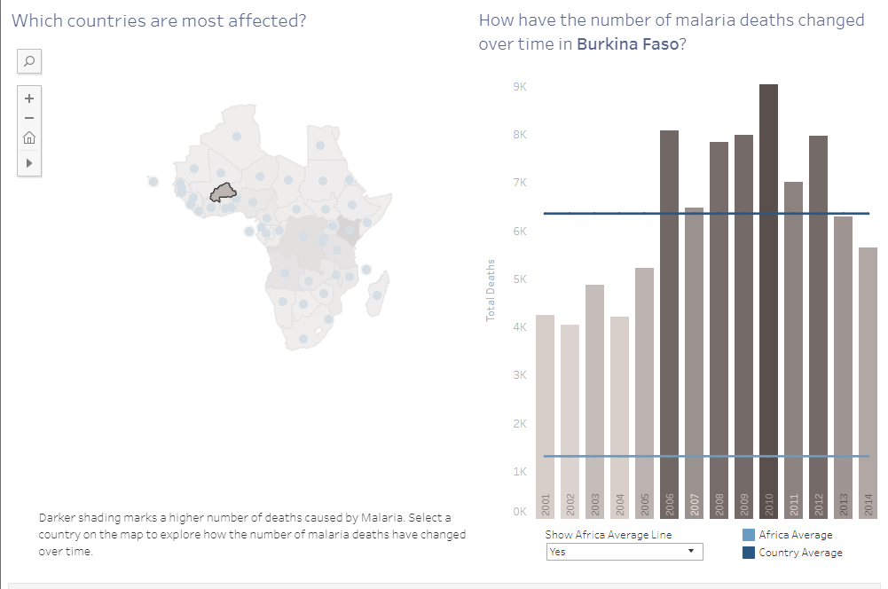

|  |  |
| --- | --- |
| Average deaths every year: 6,346  Average deaths every day: 17.39  Seeing the data of the Burkino Faso : |  |
|  |  |
|  |  |

* The average deaths in the Country are very high than that of Africa average , more than 3 times of the Africa average .
* 2010 was the worst year (with 9k deaths) for the Country in the 2001-2014 duration.
* 2002 is seen to be the best year in the 2001-2014 duration with deaths approx equals to 4000.
* 2006 -2012, this duration is seen to be the bad for the country.
* Years 2007 and 2011 have shown a downfalls in the deaths comparing to their previous years.
* There is sudden increase in deaths in the year 2006 .
* Deaths are in decreasing sequence since the year 2010 with an exception for the year 2012.
* It can be seen in medium risk level countries.

**Conclusion :**

Burkino Faso can be categorized under the medium risk countries in Africa . Deaths were in decreasing sequence since the year 2010 with an exception for the year 2012 , but the average deaths in the country are still high then that of Africa’s.

**United Republic of Tanzania**

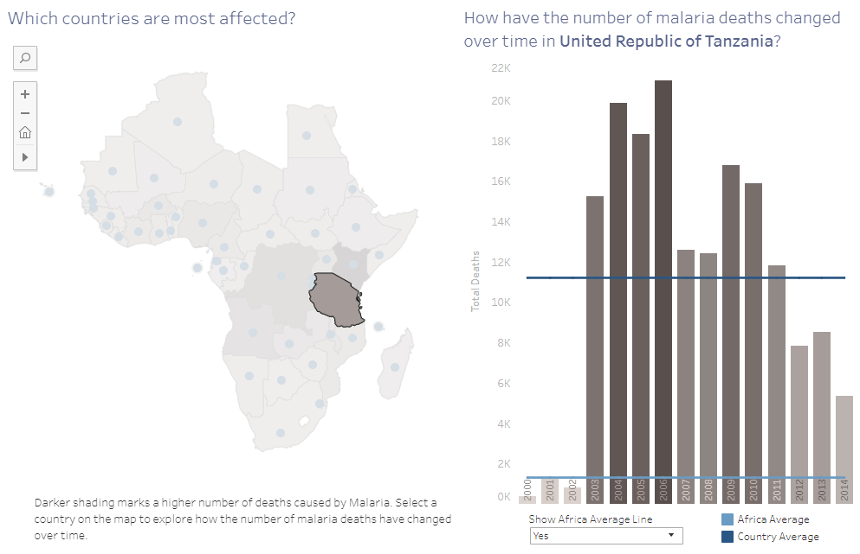

|  |  |
| --- | --- |
| Average deaths every year: | 11,201 |
| Average deaths every day: | 30.69 |
|  |  |
| Seeing the data of the United Republic of Tanzani : |  |
| * Comparing the country's average to that of Africa’s , it is 5 times more than that of Africa. * The country is worst affected after 2002 . * With a count of 1000 cases in the year 2002, there was a sudden rise to 15k by the year 2003 * 2004 and 2006 are the worst years for the country , with an death rate of more than 20k. * During the years 2000-2002 the deaths were below the average deaths in the Africa. * Deaths are in decreasing sequence since the year 2009 with an exception for the year 2013. * It can be seen in medium risk level countries.   **Conclusion :**  United Republic of Tanzani is also under the medium risk countries . But there was a sudden increase in the death rate since 2002 . Comparing the country's average to that of Africa’s , it is 5 times more than that of Africa. |  |